QTP DOCUMENT FOR cPCI BASED ADVANCED LAUNCH COMPUTER & KVM

**PURCHASE ORDER NO: ASL/DA1P/RCI/R/DA1P/0213/20/4009/4002; Date: 27-04-2021.**

|  |  |  |  |  |
| --- | --- | --- | --- | --- |
| |  |  | | --- | --- | | **PREPARED BY :** | **CHECKED BY:** | | **Mr. Purushotham Reddy**  **Application Engg**  **M/S DATASOL (B) Pvt Ltd** | **Mrs. Sabitha Rani**  **Quality Manager**  **M/S DATASOL (B) Pvt Ltd** |   **Supplied To**  MS. Advanced System Laboratory  Government of India  Defence Research & Development Organisation  Dr. APJ Abdul Kalam Missile Complex  Kanchanbagh (PO), Hyderabad -500058 |
| **Manufactured By:**  **DATASOL (B) PVT.LTD.**  “Datasol House”, #793, 17th Cross,  Vyalikaval HBCS, (Behind BEL Corporate Office),  Veeranna Palya, Nagawara, BANGALORE - 560045 |

**Record of Revisions**

|  |  |  |  |  |  |
| --- | --- | --- | --- | --- | --- |
| S/N | RevNo. | Date | Section (s) changed | Changed  By  (Datasol) | Details of Revisions |
|  |  |  |  |  |  |
|  |  |  |  |  |  |
|  |  |  |  |  |  |
|  |  |  |  |  |  |
|  |  |  |  |  |  |
|  |  |  |  |  |  |
|  |  |  |  |  |  |
|  |  |  |  |  |  |
|  |  |  |  |  |  |
|  |  |  |  |  |  |
|  |  |  |  |  |  |
|  |  |  |  |  |  |
|  |  |  |  |  |  |
|  |  |  |  |  |  |

LIST OF ABBREVIATIONS:

* SBC - SINGLE BOARD COMPUTER
* KVM - KEYBOARD, VIDEO, MOUSE
* SSD - SOLID STATE DRIVE
* RAM - RANDOM ACCESS MEMORY
* CPU - CENTRAL PROCESSING UNIT
* DVD - DIGITAL VIDEO DISK
* I/O - INPUT / OUTPUT
* PREET - Pre-Environmental Testing (Parameters to be monitored before environmental tests)
* INSET - In-Situ Environmental Testing (Parameters to be monitored during the environmental test)
* POET - Post environmental testing (Parameters to be monitored after the test completion).

|  |  |  |
| --- | --- | --- |
| **S NO** | **TABLE OF CONTENTS** | **PAGE** |
|  |  |  |
|  |  |  |
|  |  |  |
|  |  |  |
|  |  |  |
|  |  |  |
|  |  |  |
|  |  |  |
|  |  |  |
|  |  |  |
|  |  |  |
|  |  |  |
|  |  |  |
|  |  |  |
|  |  |  |
|  |  |  |
|  |  |  |
|  |  |  |
|  |  |  |
|  |  |  |
|  |  |  |
|  |  |  |
|  |  |  |
|  |  |  |
|  |  |  |
|  |  |  |
|  |  |  |
|  |  |  |

### 1.0. SCOPE

This Acceptance test procedure document (ATP) for c**PCI BASED ADVANCED LAUNCH COMPUTER & KVM** presents the complete design and operational aspects of c**PCI BASED ADVANCED LAUNCH COMPUTER & KVM** System developed by M/s Datasol (B) Pvt. Ltd. Bangalore.

This document gives the technical specification of the c**PCI BASED ADVANCED LAUNCH COMPUTER & KVM** system and design details of each sub module to meet the specification of overall system. The document covers the block diagrams of overall system as well as its sub modules and test set up details.

**1.1. System Description**

1. CPU which will be 19” rack mountable unit with maximum depth of 450mm and Maximum, Height of 4U
2. Monitor & Keyboard together which will be a separate 2U height 19” rack mountable unit with foldable monitor assembly
3. Slides assembly for both the above units
4. Interconnection cables & power cables

**1.2 . System Specification:**

**1.2.1. cPCI chassis :**

The description of the mechanical assembly is given in the following section.

cPCI chassis will be a 19” rack mountable unit with 4U height. The unit is equipped with rack mountable slides for easy access. Doors are provided in the front and rear side. Opening these doors will give easy access for the card IO’s . ON/OFF switch & LED indicators are provided on front to show the status of the unit

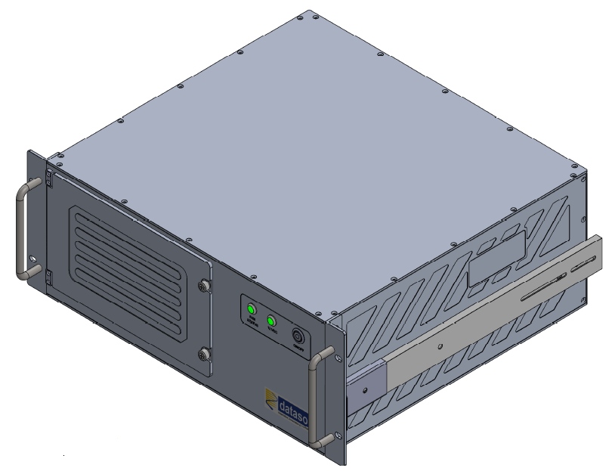

cPCI chassis Image

**KVM:**

The total Hight of KVM is 2U, 1U is for display (Top plate) and 1U is for keyboard (Bottom plate). The KVM will be 19” rack mountable. Slides are fixed to the KVM unit for mounting it on the rack and also for easy access.

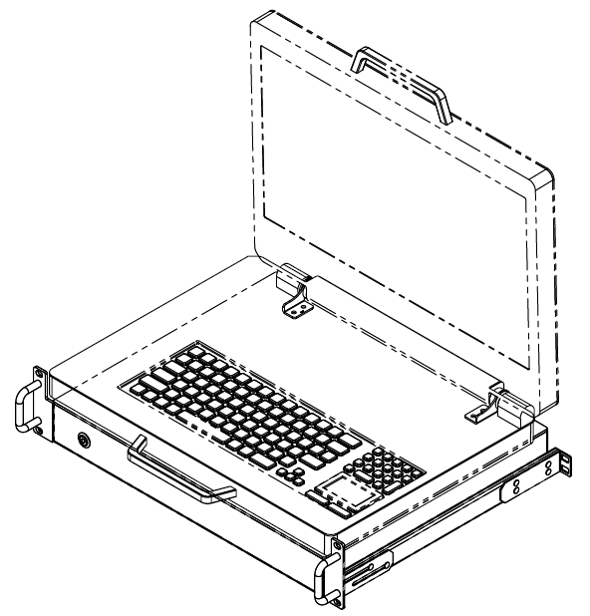

KVM Image

### 1.2 REFERENCE DOCUMENTS

The following list of references may be helpful for you to understand the concept of the custom design.

ATP: Acceptance Test Procedure.

### 1.3 LIST OF DELIVERABLES

As per the Purchase Order Deliverable are listed below:

|  |  |  |
| --- | --- | --- |
| **SL No** | **Item Description** | **Quantity** |
| 1 | **Model No: -**  cPCI Based Advanced Launch Computer | 20 Sets |
| **Model No:**  19” rack mount 2U, 18.5 /19” Display with keyboard and touchpad with mating cables. |
| 2 | Cat 6 Gigabyte Ethernet cables terminated with RJ45 connectors – 10m length | 20 Sets |
| 3 | Cat 6 Gigabyte Ethernet cables terminated with RJ45 connectors – 5m length: | 20 Sets |
| 4 | VGA Splitter for extending VGA output up to 50m (Startech or EQVU) | 05 sets |
| 5 | Red Hat Enterprises Linux 7.5 or Higher Workstation license and media | 02 Nos |
| 6 | External USB based DVD drive | 05 Nos |
| 7 | Display Port/DVI to VGA adaptor cable of length 3m (Startech or EQVU) | 10 Nos |
| 8 | Circular power cable for KVM | 20 Nos |
| 9 | Packing Box for cPCI Chassis | 20 Nos |
| 10 | Packing Box for KVM | 20 Nos |
| 11 | Power Cord for cPCI Chassis | 20 Nos |
| **SPARES** | | |
| 1 | 3U cPCI XMC Carrier Card | 5 no’s |

### TECHNICAL SPECIFICATION'S FOR cPCI CHASSIS :

|  |  |
| --- | --- |
| **CPU** | Intel® Core™ i7-5700EQ Processor 2.6GHz, 3.4GHzTurbo |
| **RAM** | 8 GB DDR3L-1333 SDRAM ECC soldered |
| **ETHERNET** | 3 Ports |
| **USB** | 3 x USB |
| **SSD** | 1TB 2.5’’ SSD |
| **VGA** | 1 x VGA on RTM |
| **DVI** | 1 x DVI on SBC |
| **XMC GPU** | 1 x DVI |
| **POWER** | 230V AC Power supply |
| **OPERATING TEMPERATURE** | -20 to 70° C |
| **POWER CONSUMPTION** | 200 W MAXIMUM |
| **OPERATING SYSTEM** | RHEL 7.5 & above |

### TECHNICAL SPECIFICATION'S FOR KVM:

|  |  |
| --- | --- |
| **DISPLAY SIZE** | 18.5” |
| **RESOLUTION H x V** | 1920 x 1080 |
| **USB** | 1 x USB |
| **DVI** | 1 x DVI on REAR SIDE |
| **KEYBOARD WITH TOUCH PAD** | 1 x keyboard with integrated touch pad |
| **POWER** | 230V AC Power supply |
| **OPERATING TEMPERATURE** | -20 to 55° C |

### TEST SETUP:

## 2.0. IDENTIFICATION

## 2.1. cPCI Chassis Identification

The “cPCI BASED ADVANCED LAUNCH COMPUTER” supplied by DATASOL to ASL, Hyderabad will be hereafter identified as given below.

System : cPCI BASED ADVANCED LAUNCH COMPUTER

Part No **:** xxxx

S/N : xxxx

**Fig : cPCI Identification Image**

**Note:** Please suggest if any other details to be mentioned in above identification details (Name plate)

## 2.2. KVM Identification

System : KVM

Part No : xxxx

S/N : xxxx

**Fig : KVM Identification Image**

**ENVIRONMENTAL TESTING :** These tests are done to test and evaluate performance of the time(s) at the specified environmental conditions.

**Note:** As PO mentioned in 2.5 Environmental specification /testing, One unit is to be selected randomly and batch acceptance tests are to be carried out on this unit as per QA Document mentioned in para 2.6 (a, b, c)

**Entest Applicable Matrix For The Items**

|  |  |  |  |  |  |  |  |
| --- | --- | --- | --- | --- | --- | --- | --- |
| **Sl No** | **GSE** | **EMI/EMC** | **ESS\*** | **Damp**  **Heat** | **High**  **Temp.** | **Low Temp** | **Random**  **Vibration** |
| 1 | cPCI Based Advanced Launch Computer | NA | **A** | **A** | NA | NA | NA |
| 2 | KVM | NA | NA | **A** | **A** | **A** | **A** |

**Batch ENTEST Specifications for Class -2B GSE With LCD Display**

| **Sl. No.** | **Description** | **Specification** | **Remarks** |
| --- | --- | --- | --- |
| 1 | High Temperature | +55°C±3° for 4 Hours | PREET , INSET & POET  INSET in Last 30 Min |
| 2 | Low Temperature | -20°C±3° for 4 Hours | PREET , INSET & POET  INSET in Last 30 Min |
| 3 | Damp Heat | 450 C (RH 95%) for 8 Hours | PREET at ambient  INSET at 7 ½ Hours. |
| 4 | Random Vibration (Three axis) | 5-20 Hz, (6db per octave)  desirable 20-50 Hz:0.02g2/Hz  then rolling down to 0.001g2/Hz at 500 Hz.  **Duration:** 30 minutes cumulative in 3axis | PREET , INSET & POET |

**Note:** Since KVM is inside the chamber, We can not test the Keyboard & Touch pad functionality.

**ESS Test Details for cPCI Based Advanced Launch Computer**

|  |  |  |  |
| --- | --- | --- | --- |
| **S.No** | **Parameter** | **Test Description** | **Remarks** |
| 1 | Thermal cycling | Temp Range: -20° C to +55° C  Dwell Time : 60 Min  Rate: AT 10° C/Min  No.of cycles: 6 | PREET & POET at ambient.  INSET 2 times every cycle:  1st before switching OFF at the end of higher temp dwell period. And, 2nd after switching ON at the end of the lower temp. dwell period. |
| 2 | Damp Heat | 45° C, RH 95%, for 8 Hours. Duration | PREET , INSET & POET  INSET at 7 ½ Hours |